TY CSE AY-2022-23 Sem-I
Artificial Intelligence and Machine Learning Lab
Assignment No 3 Due date- 14/09/2022
NAME:VISHAL INDRADEV CHAUHAN
PRN:2020BTECS00090
BATCH:T-6

- The game Undercut consists of a sequence of moves in which two players simultaneously choose an integer between one and five, both inclusive. Each person gets the number she chooses as her score for that round, except when the opponent has chosen a number smaller than hers by one, in which case the opponent gets both the numbers for example, if A chooses 5 and B chooses 3 then A gets 5 and he gets 3. But if A chooses 5 and B chooses 4, A gets nothing and B gets 9.
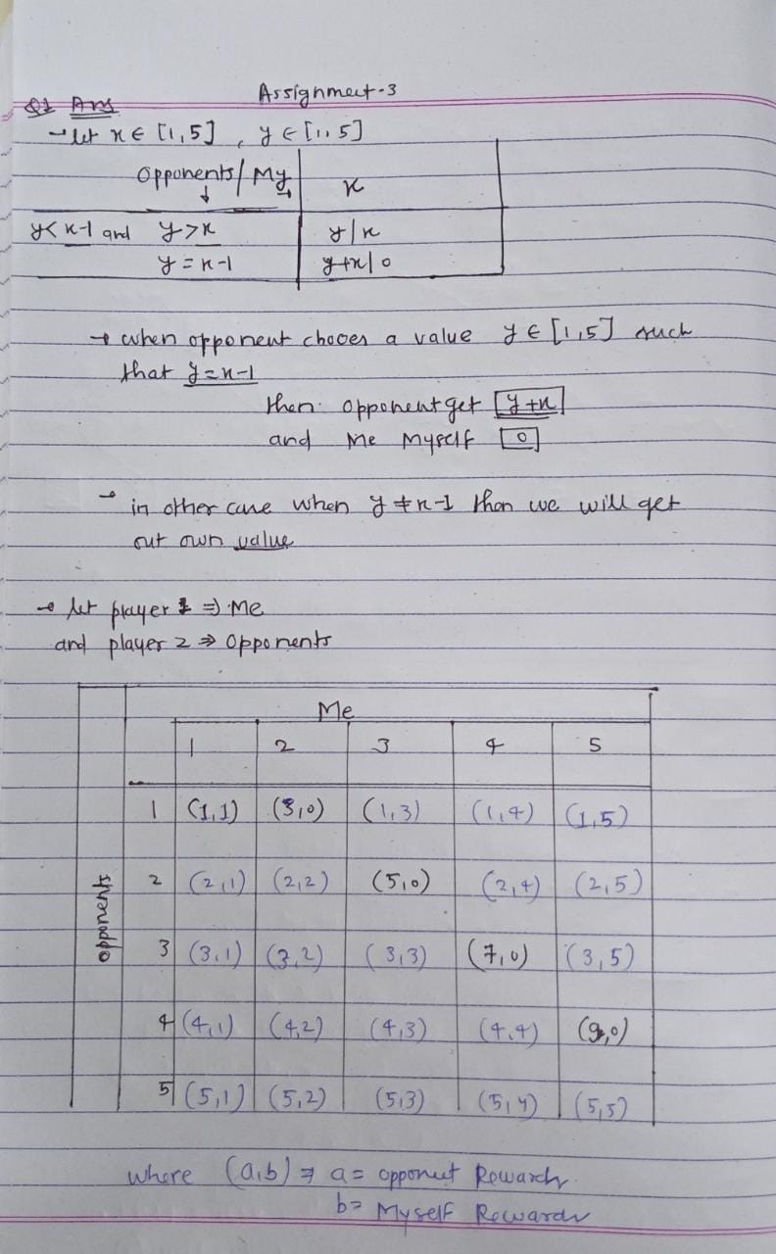

- To identify the optimal move in the game tree given below, implement

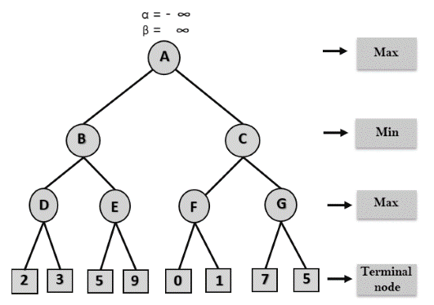

- Min Max algorithm
- Alpha Beta algorithm
Which algorithm is efficient? Why? Justify.
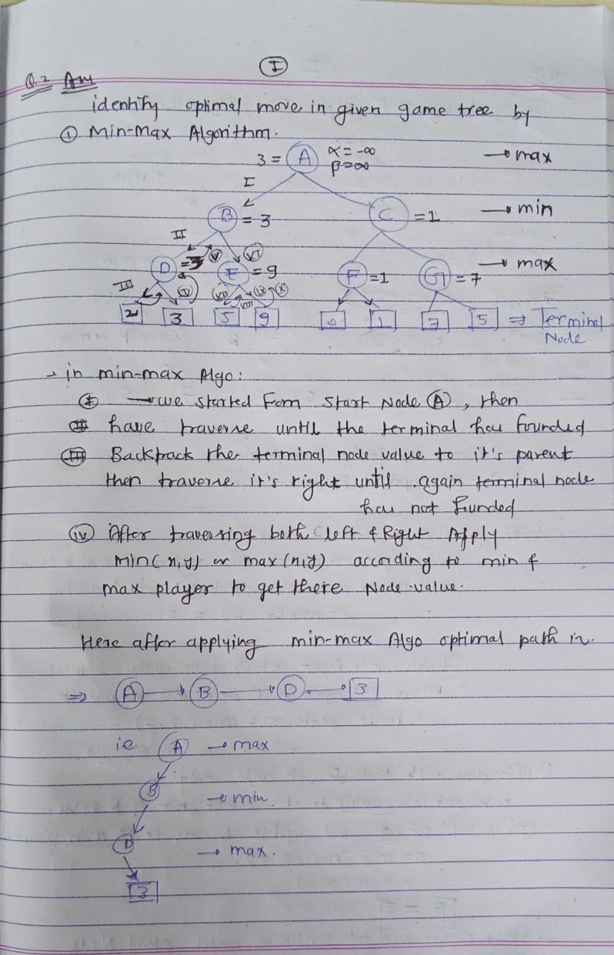
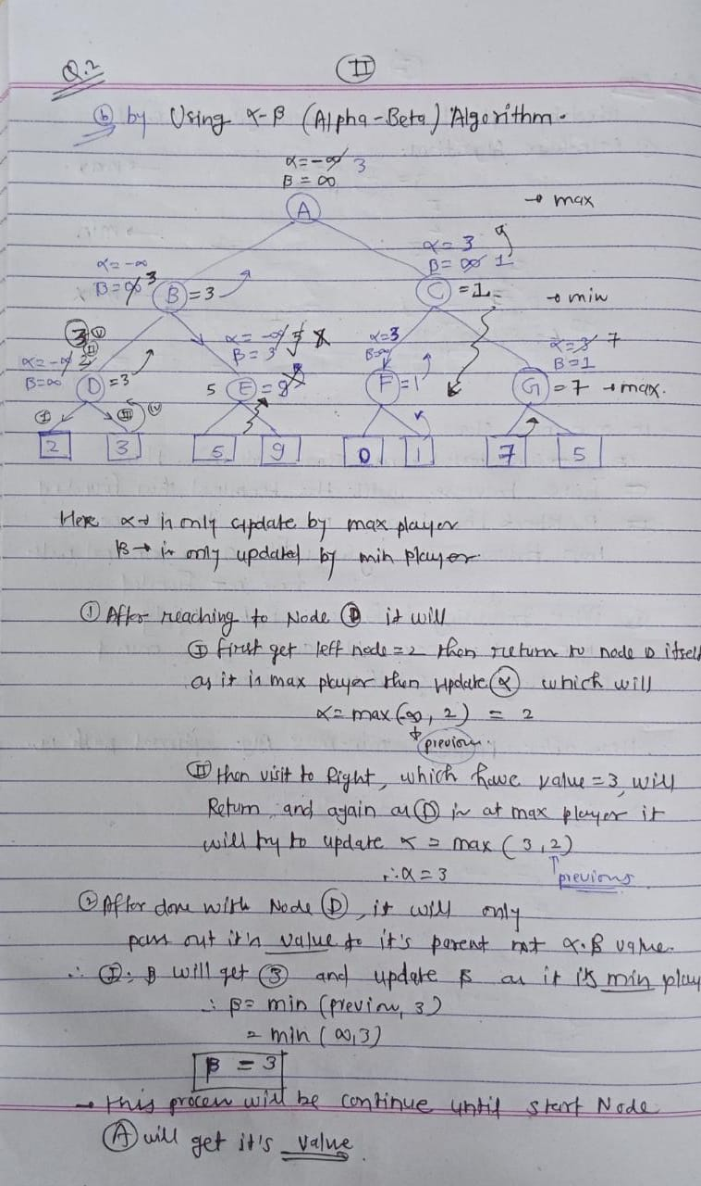
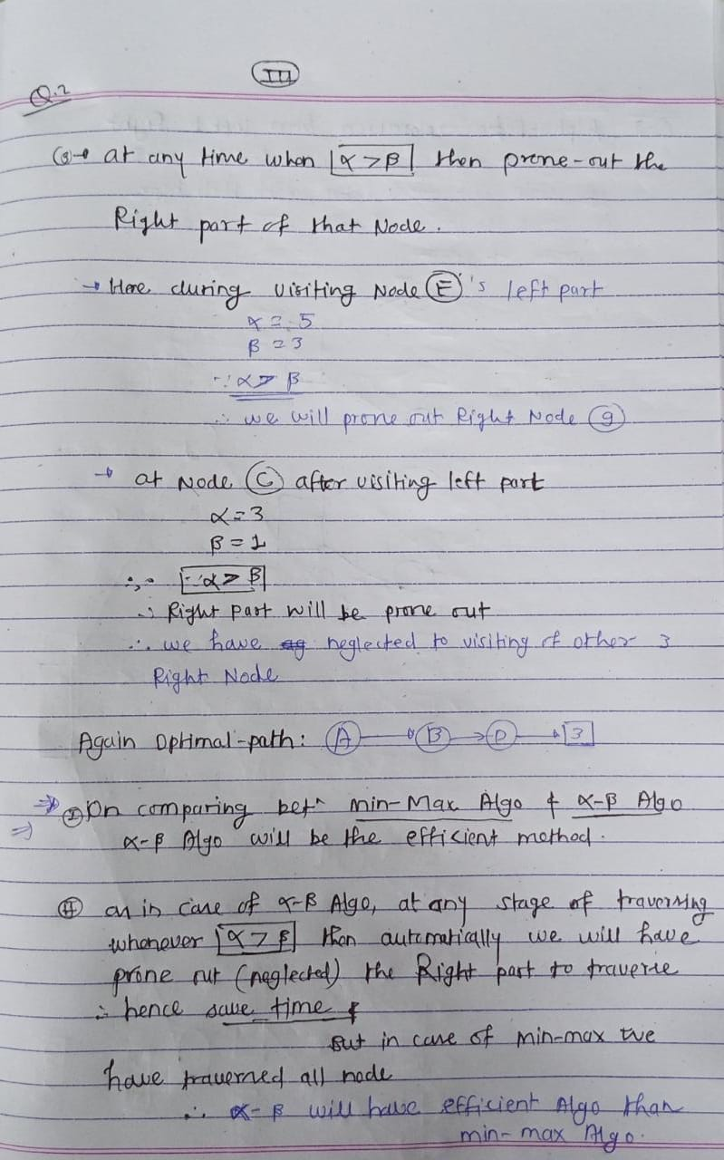

- Show how the algorithm AlphaBeta explores the game tree, searching from left to right.
(a) Fill in the leaves that are inspected by AlphaBeta.
(b) Show the cutoffs and label them with their type.
(c) Mark the move that AlphaBeta will choose for MAX at the root.

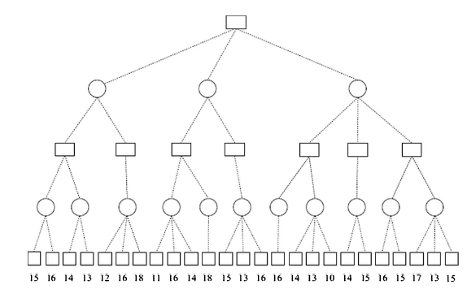
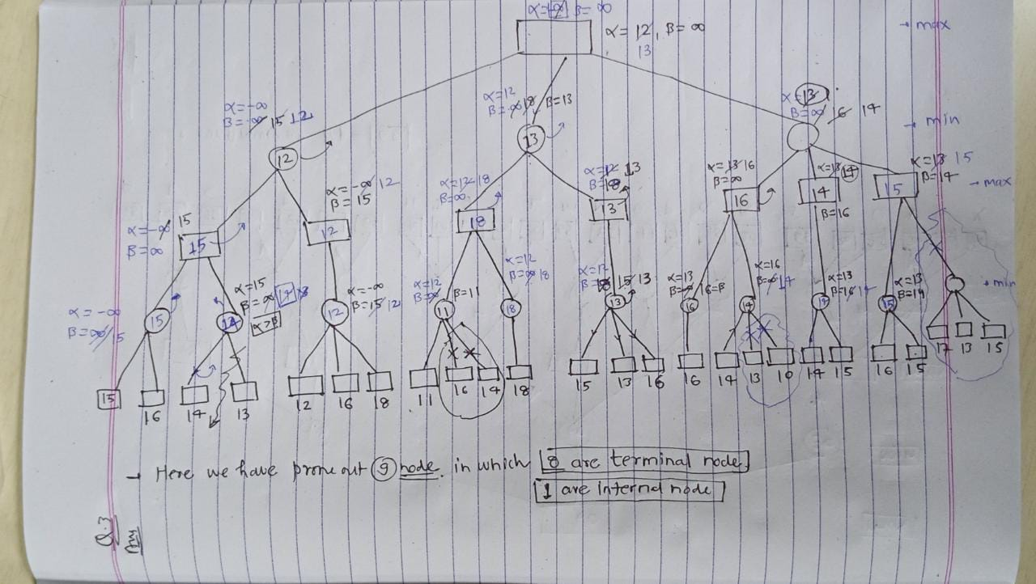

- In the game tree on the following page, the leaves are labelled with the values from the evaluation function. The letter labels [A ... X] below the leaves are names of the leaves. Show the order in which algorithm SSS* will inspect the nodes, explaining all the decisions made, along with diagrams where appropriate. What is the minimax value of the game?




